|  |
| --- |
| CSCI 6461 Computer Simulator |
| User Guide |
| Lulwah AlKulaib Amirah Abdulrahman Yichen Zhou Han Wang |
|  |
|  |

**Phase I: Basic Machine**

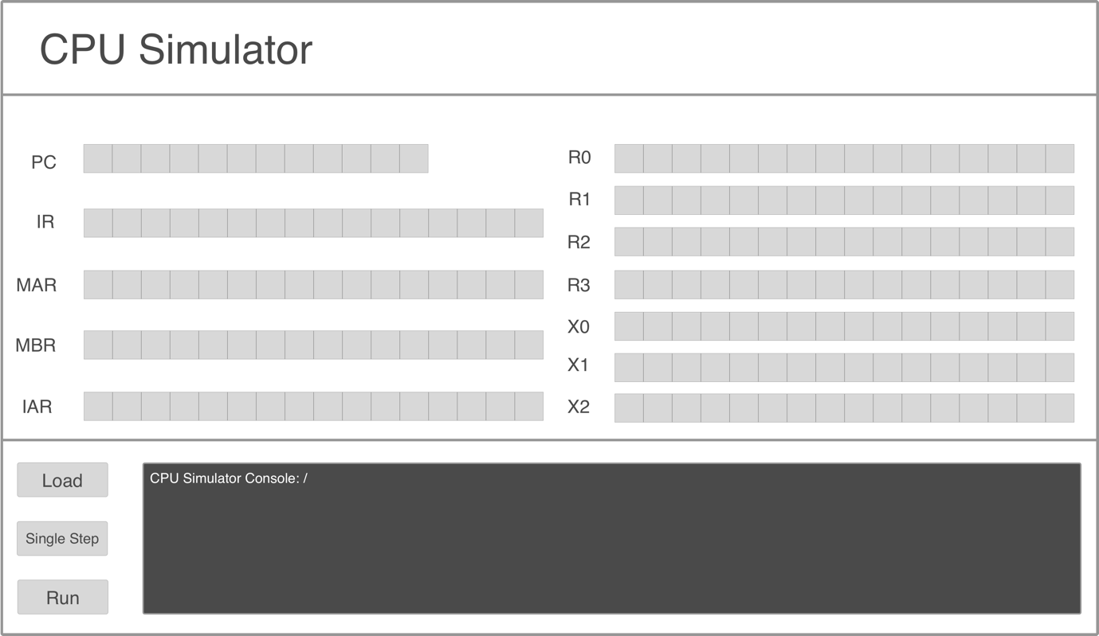

2

1

3

Figure 1: GUIPanel Display

* When the Jar file runs the GUI in ‘Figure 1’ will be displayed.
* The GUI consists of three parts:
  1. Each of the registers in the first column exists to hold certain information:
     + PC: displays the current instruction that is being executed.
     + IR: displays the currently executing register.
     + MAR: displays the memory address of the data to be fetched.
     + MBR: displays the data fetched from and to the memory.
     + IAR: displays the address of the current executing register.
  2. Registers R0-R3 are General Purpose Registers, Registers X0-X2 are Indexed Registers.
  3. CPU Simulator Console: is the control area for the user to load files, run the program and monitor the output. It consists of the following:
     + Load Button: Loads a text file of instructions into memory.
     + Single Step Button: Loads memory contents one instruction at a time, and changing register values accordingly
     + Run Button: Loads all instructions in memory sequentially into registers and displays values on the console (For now. It will later perform instruction execution in coming phases).
     + Simulator Console: A console to display messages and output to ensure correctness.

|  |  |  |  |
| --- | --- | --- | --- |
| Version No. | Version Date | Author | Description |
| 0.1 | 02-05-2017 | Han Wang, Lulwah AlKulaib | Phase I: Basic Machine |
|  |  |  |  |
|  |  |  |  |
|  |  |  |  |